**RESEARCH NOTE**

Date: 30/05/2022

Name: Prakash S

**Project Title: Identification of Environmental Parameters for Seaweed Cultivation**

**Introduction:**

Seaweeds are nothing but marine macroalgae that are grown in subtidal and intertidal regions of the coastal areas. These seaweeds play a vital role in the food web and act as an energy base for all aquatic organisms in the marine ecosystem. Because of its nutrition content of high protein, vitamins, and minerals, the consumption of seaweed has enormously increased nowadays. And it is the only non-fish source that contains omega-3 fatty acids. Seaweeds provide raw materials for industries such as pharmaceuticals, cosmetics, fertilizers, and animal feed. It has it contributes to ecosystem services such as eutrophication mitigation, carbon capture or sequestration, ocean acidification amelioration, habitat provision, and shoreline protection.

Several seaweeds are structuring species in coastal zones, changing the environment (by modifying light, sedimentation rates, and hydrodynamics). Seaweeds are part of food webs and give ecosystem services such as habitats, food, and refuge to a diversity of associated organisms (which are of conservation and economic importance) from different trophic levels (apex predators, fishes, and invertebrates) and therefore support biodiversity. In addition, marine seaweeds contribute to the coastal defense by reducing the hydrodynamic energy from waves and by maintaining a high bed level at tidal flats, thus protecting those tidal areas from erosion.

Currently, many Indian seaweed-based industries are not producing agar to their full capacity due to raw material shortages. Several attempts have been made to develop Cultivation methods for *G. edulis* employing a long-line rope, net-culture, and single floating-rope techniques. However, the major disadvantage of these methods is the loss of the crop due to breakage of the plants from the substrate, particularly during rough weather.

**Culture Methods used in India:**

Bamboo raft method:

Floating bamboo raft method is ideal in locations which are calm and shallow. The floating raft is made of bamboo with dimensions of 12’ × 12’ for mainframe and 4’ x 4’ for diagonals. In each raft, around 20 polypropylene-twisted ropes are used for plantation. Around 150 – 200 grams of seaweed fragments are tied at a spacing of 15 cm along the length of the rope.

Longline or monoline method:

In locations characterized by moderate wave action, shallow depth and the presence of less herbivorous fishes, longline or monoline method of seaweed farming is ideal the poles are interconnected using a 6mm rope and the seaweed seedling rope is fastened to this. Around 150 grams of seaweed fragments are tied at a spacing of 15 cm along the length of a rope and a single rope contains around 40 fragments.

Tube net method:

The tube net method can be adopted in locations with higher wave action in coastal states like Andhra Pradesh and Gujarat. The tube nets (10 cm diameter; mesh size of 1.5 cm) of 25 m length are held floating in the water column below the surface with an appropriate number and size of floats at regular intervals.

**India’s part in Global seaweed production:**

In 1960 the global production of seaweed is nearly about 2.2 million tonnes and was evenly contributed by wild collection and cultivation. Even half a century later, the wild species collection is still 1.1 million tonnes, but the cultivation of seaweed has increased to 34.7 million tonnes which accounted for 97% of the total world seaweed production in 2019 (Cai et al.,2021). In 2019, the contribution of Asia toward global seaweed production is 97.38%, of which India’s contribution along with 7 other countries is 0.12%. India has a coastline of about 7516.6 km spreading across 9 maritime states and this 0.12% contribution clearly depicts that India is lagging in utilizing its potential coastal areas (FAO). India nearly produces about 20040 tonnes of seaweed every year with an annual turnover of Rs.200 crores. But that does not even contribute to 1% of the global seaweed production.

**Reason behind India’s Less production:**

Lack of knowledge, inadequate marine spatial plans, improper implementation strategy, public unawareness, seed unavailability, and unreliable data could be the cause of the less production of seaweeds in India.

**Why to study growth parameters of seaweed?**

The very most important question to be addressed before starting seaweed cultivation is the selection of a suitable site based on the ideal growth parameters of seaweed. Site selection plays an important role in the success of any sustained commercial farming activity. It significantly influences the economic returns and viability of the farming system. For the good biomass production, understanding the growth of seaweed based on environmental and hydrodynamic aspects is utmost important to achieve good economic return. This basic understanding can be able to save farmer/entrepreneur/govt agencies from getting failure in seaweed farming.

**Beneficiaries:**

Coastal fisher-families, especially fisherwomen, their societies/ SHGs, and farmers/ entrepreneurs.

**Generalized Ideal Conditions followed for Seaweed cultivation in India:**

The optimum conditions are provided by NFDB, India.

• Stable seawater with not less than 30 ppt salinity

• Sandy/ rocky bottom with transparent water

• Ideal temperature 26-30oC.

• The area should have minimum 1.0 m water depth during low tide.

• Area with mild water currents is preferred.

• pH = 6.5 to 8.5

• Nutrient = Sites with sufficient Nitrate-Nitrogen and phosphorous

**Research Gaps:**

* Less availability of data related to culturable seaweed species in India.
* Detailed marine spatial analysis for the identification of potential seaweed farming sites.
* Innovation in seeding technology of seaweed.

**Some negative effects on the environment due to the mass production of seaweed:**

* Reduction of phytoplankton on the cultivable area of seaweed due to higher intake of Nitrogen.
* Hampers the natural Hydrodynamic conditions existing on the site.
* Artificial Habitat creation

**Sustainable approach:**

* Effective utilization of nitrogenous wastewater by cultivating seaweed.
* Integrated Multi-Trophic Aquaculture system

**Objective of Paper:**

This paper deals with detailed study and analysis of environmental and hydrodynamic parameters on the growth of seaweed. Each species of seaweed has its own unique requirement for the growth. The primary focus of the study is on the cultivable commercial important species of India.

Collection of data from literature regarding growth of seaweed-based on different parameters.

A paper that gives basic understanding of the impact of Environmental parameters on the growth of seaweed.

Listing out different species of seaweed and their ideal growth condition from the available literature.

**Futuristic development from this paper:**

Using the available data and from oceanographic data we can identify which geographical location is suitable for which kind of seaweed.

**Observations From Literature Related to Seaweed Growth w.r.t Different Parameters:**

**1. Species name***: Gracilaria tenuistipitata*

**Study parameters:** Temperature, Salinity and pH

**Observations:**

* When pH is not in control, the main factor influencing growth is Temperature (@ salinity of 20 ppt) & @ salinity above 39 ppt the growth rates were similar at 20°C and 30°C .
* When pH is under controlled condition, maximum growth rate happened at 39 ppt.
* At pH 9 the growth rate reduced to 50% when compared to growth rate at 6.5 pH.
* Outdoor cultures exhibited four times faster growth rate when compared to laboratory culture systems.
* The growth rate is higher at 20oc at all salinity range (20,30 & 39 ppt)
* At all pH range (6.5,7,8 & 9) the growth rate is higher for 39 ppt salinity condition.
* Growth experiments suggest that *Gracilaria tenuistipitat* is tolerant to a broad range of salinities with some additional benefit at 20 ppt.
* Decreasing temperatures inhibited the growth of plants in 20 ppt and 30 ppt salinities, whereas growth rates were unaffected in regular seawater. In addition, growth was strongly stimulated at 39 ppt and at a pH of 6.5 and 7.0.

**Reference:**

Alvaro et al., “Effect of salinity and pH on growth and agar yield of *Gracilaria tenuistipitata* var. *liui* in laboratory and outdoor cultivation”. Journal of Applied Phycology 11: 543–549, 1999.

**2. Species Name:** *Hypnea cervicornis*

**Study parameters:** Salinity and Temperature

**Optimum Growth Conditions:** The optimum salinity and temperature conditions for growth are 25 and 25°C, respectively.

**Observations:**

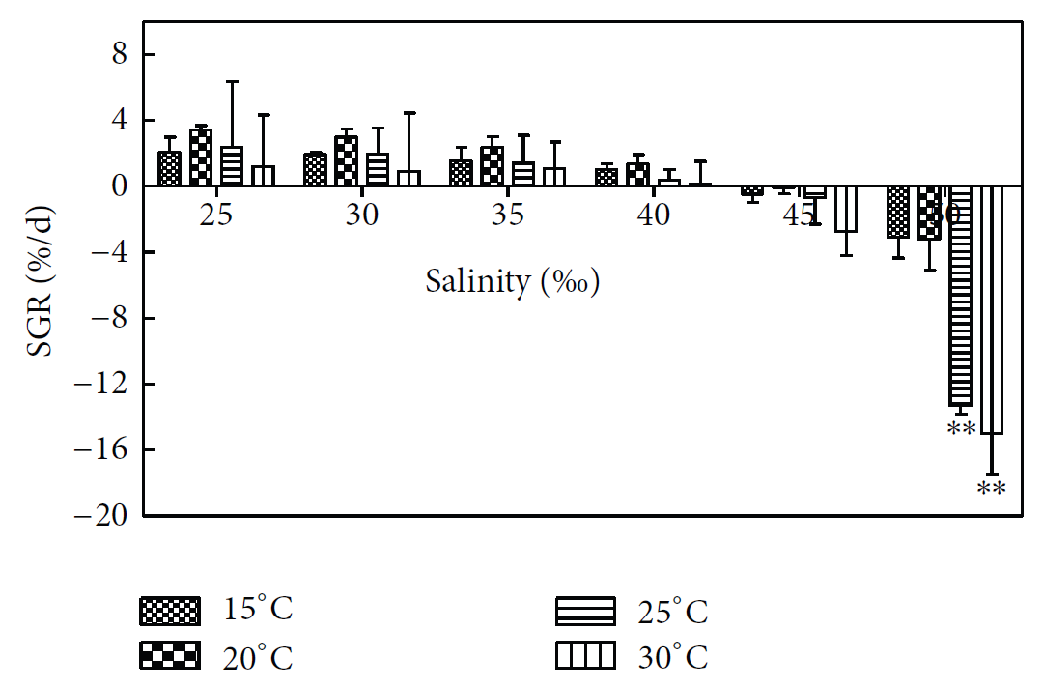

* Although the growth is slow in 15°C, the death rate is low, so it is speculated that low temperature is suitable for preservation.
* The death rates of *H. cervicornis* in 15°C and 20°C in high salinity (45 and 50) are also much less than in temperatures of 25°C and above; therefore, if the culture time is not long, *H. cervicornis* can adapt to a temperature of about 25°C.
* Guist et al., found that the biomass of *H. musciformis* increased by 20% every day and the growth rate was the highest when the water temperature was 18–24∘C, which was inversely proportional to the biomass and to the level of solar irradiance.
* *H. cervicornis* can grow in range of salinity 25–40, but the growth rate constantly decreases above salinity 40. If salinity is too high, photosynthetic activity of *H. cervicornis* will be affected and further influence its growth. If the salinity is too low, the photosynthetic activity of *H. cervicornis* is not high.

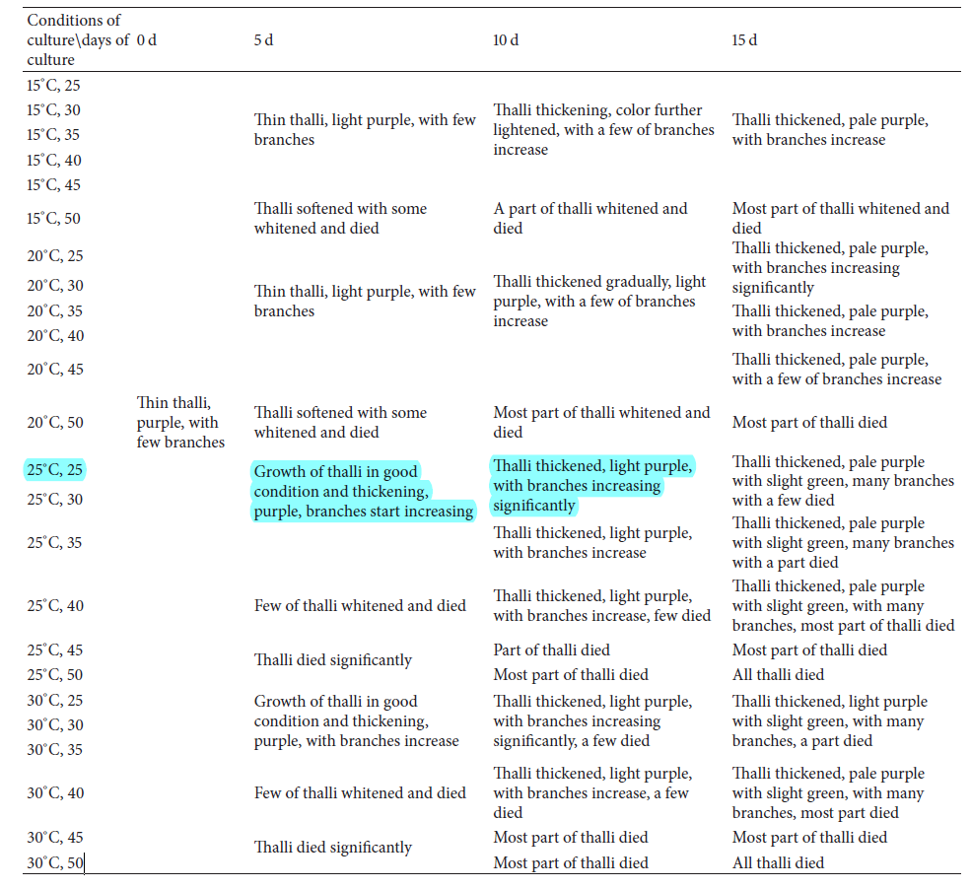The highlighted part indicates that the species *Gracilaria tenuistipitata* grown best under the condition of temperature 25°C and salinity of 25 ppt.

**Reference:**

Lanping et al., “Effects of Seawater Salinity and Temperature on Growth and Pigment Contents in *Hypnea cervicornis* J. Agardh (*Gigartinales, Rhodophyta*). BioMed Research International Volume 2013.

**3. Species Name:** *Gracilaria edulis*

**Study parameters:** Research on seasonality of growth, growth rate differences in different localities, subtidal (off-shore) and intertidal (near-shore) cultivation and seasonal occurrence of epiphytes was carried out.

**Observations:**

* Cultivation in subtidal region gave significantly higher biomass (12.5±0.9 kg fresh wtm2) and Daily Growth Rate (DGR) (7.4±0.4%/day) than those from intertidal region (4.4±0.4 kg fresh wtm2) and DGR (5.1±0.1%/day).
* Epiphytes are reported to cause severe problems for the growth of *Gracilaria*.
* In India, 32 species of *Gracilaria* have been reported (Krishnamurthy, 1991). Among these, *Gracilaria edulis* is more abundant and utilised for more than two decades for agar production.
* The commercial beds of G. edulis are mostly restricted to the Gulf of Mannar, south-east coast of India.
* The correlation coefficient results from the dataset presented in this study indicated that amongst the various environmental factors, surface seawater temperature (SST) was an important determining factor for the seasonal growth of *G. edulis*.
* SSTs recorded during the maximum growth period (i.e.October–December) was “moderate”, e.g. between 24 and 28 °C for the 3 years.
* McLachlan and Bird (1986) claimed that *Gracilaria* species from warm water areas showed maximal growth and highest productivity at 25–30 °C.
* The optimum temperature of 25°C was reported for the growth of *Gracilaria tikvahiae* (Hanisak, 1987; Lapointe et al., 1984).
* For *Gracilaria verrucosa* (Hurtado-Ponce and Umezaki, 1987) and *Gracilaria conferta* (Friedlander, 1992) whilst the maximum growth rate of *Gracilaria cornea* was reported at 26°C (Rojas and Robledo, 1999).
* The higher growth rates for *Gracilaria gracilis* were observed between 21.5 and 25.5°C (Robello et al., 1996).
* Members of the genus *Gracilaria* do not grow at SSTs exceeding 30 °C (McLachlan and Bird, 1986). The high SST (29 °C) during the summer months in India may limit algal growth.
* Deterioration and disintegration of G. edulis thalli were noticed during first week of April. This could have been due to the high SST (29.5 to 30 °C), relatively low water currents, or upwelling of sediments and, this was also the period when the greatest number of epiphytes was observed.
* *G. verrucosa* from China was also reported to disappear from the intertidal zone when surface water temperature rose to 30 °C and above. *(Wang et al., 1984).*
* In addition to SST, the seasonality of harvested biomass and DGR of *G. edulis* were not influenced by salinity.
* High nitrate concentration significantly correlatedwith higher biomass and DGR of *G. edulis* in Ervadi. Nitrate enhanced reproductive activity in G. gracilis (Soriano et al., 1998).
* Bird et al. reported increase in growth rate of *G. verrucosa* at higher nitrate concentration.
* Arano et al*.* (2000) found moderate concentration of nitrate resulted in a higher growth rate in 3 species of *Gracilaria.*
* The maximum DGR value (7.4%/day) reported in the present study is higher than reported for long line rope method (1.31 to 3.37%/day), coir rope method (2.25 to 3.47%/day) and single rope floating method (5.48%/day) for *G. edulis* cultivation.
* The results of the present study revealed that *G. edulis* can be cultivated for 8 months in a year along the southeast coast of India. July to February is the ideal period for the large-scale cultivation of this alga.

**Reference:**

M. Ganesan, Nivedita Sahu and K. Eswaran. “Raft culture of Gracilaria edulis in open sea along the south-eastern coast of India”. Aquaculture 321 (2011).